Charlie Nitschelm  
Satellites  
01/25/2020

Planet Labs Flock

When people think of satellites, they think of bus size pieces of equipment that have been under development and manufacturing for decades. But many satellites are quite the opposite. As technology has continued to improve since the Apollo era, the pieces of equipment needed to perform the necessary tasks have become smaller and smaller. With that, for many businesses coming forth from the commercial space sector, it does not make sense to make huge satellites anymore. It is much more cost effective to produce a smaller satellite with a very specific function to reduce development and manufacturing costs, not to mention the cost to bring it to its orbit.

Planet Labs is a private Earth imaging company basic in San Francisco, California dedicated to providing earth imaging as a service to companies and governments. Although Planet designs and manufactures their satellites constellation, the company has also acquired other Earth-observing satellites from other commercial startups, including RapidEye and SkySat1. Although these satellites help their mission of earth-wide observation daily, their personal satellite fleet called ‘Flock’ will be discussed in greater detail.

In April of 2013, Planet launched its first 2 experimental satellites called Dove 1 and 2. These satellites were launched on a Antares 110 and a Soyuz rocket. The satellites weighed 6 kg, sometimes orders of difference in weight and volume then other satellites being launched. Due to this, they can easily ‘rideshare’ with other companies/governments that are going to the same desired spot. For Dove 1 and Dove 2, that was sun-synchronous orbit. It allowed for the CubeSat to leverage its solar-powered system to maintain constant communication with the ground and to always observe the Earth where these is sunlight. This orbit is 280km x 270 km, 51.6° 2. As a short experimental mission, it was placed into an orbit to last 6 days, but in that time, the satellites could capture images of earth and discern individual trees2.

As the tech was proven, in June 2013, the company ‘’announced the plans for ‘Flock-1’, a constellation of 28 Earth-observing satellites1.” Each satellite weighted 4 kg and produced constant images of earth with 3-5 meter resolution. They launched it at an orbit of 400 km (slightly higher then the Dove series). In just one year, you can see that the company managed to reduce weight, launch further away to extend lifetime, and keep the same resolution as the Dove series with the Flock-1 constellation. The Flock-1 satellites were launched in January 2014 and inserted via the NanoRacks CubeSat Deployer1. The data obtained from this constellation pushed Planet Labs to a huge competitor in the Earth-observation industry and raised more capital from investors. The constellation then suffered a significant loss with the off-chance event of two back-to-back rideshare launch mission failure from the Orbital ATK Antares rocket and a SpaceX Falcon 9 rocket. This set back the constellation creation by 34 satellites, but the company pushed forward3.

Figure 1 - The rapid, unscheduled disassembly (RUD) of the Antares rocket carrying 26 Flock satellites, the largest amount of satellites lost in a single launch3

The main advantage of the Flock design, and its small, efficient size is constant innovation. The technology required for all its systems, including power, telemetry, communications and imaging can be constantly improved with each launch and customer feedback on the data. Instead of having a decade long project for one satellite with old tech embedded into the systems, Planet Labs and the Flock can continuously improve4. The Flock is manufactured mostly from commercial off-the-shelf parts, all build and assembled in house. As the industry improves, so does the ability of the satellites3.

Figure 2 - Clean room of Flock satellites by Planet Labs, detailing the small, mass production methadology to satellite constellations3

As the years pushed forward, the company continuously managed to increase its flock size with more launches of additional satellites in orbit. To the day of this writing, there are currently 198 Flock satellites in orbit continuously obtaining images and needed data from Earth1. With its fleet, and manages to get updated images of Earth more then twice a day in nearly every area on Earth excluding very remote location near the poles of Earth.

From the company’s website, it is quite impressive how easy the company makes it to use their service and connect with such a complex system so seamlessly. When you picture this company and their Flock constellation, you think only governments can really use this information, but the implications that this data can impact is quite large spanning many industries. As we explore the uses and abilities of a satellite, and its progression over the years, it is also extremely important to zoom out and ask the question ‘why?’ The information from these images and the data analysis that Planet Labs offers to its customers can be extremely valuable. The data is bought by companies and organization within the agriculture industry to monitor large fields, manage their crops and improve yields4. It is used by education and research to get information on Earth, monitor constant change, and make discoveries. Emergency management wants the service, as they can monitor events, improve response and drive resilience. Civil government can map land use, manage their resources and monitor overall urbanization in cities, states and countries. Insurance companies need constant Earth imaging to understand risk, accelerate claims and detect fraud on a world-wide scale. Energy and infrastructure use the satellite constellation data to oversee assets, monitor competition, and mitigate disaster5. Outside of most monetary organizations, it also has a huge humanitarian affect, which is primarily most important to their overall mission. They can release public images of the affect humans have on Earth, or the horrors we can do to each other that can be seen from space.

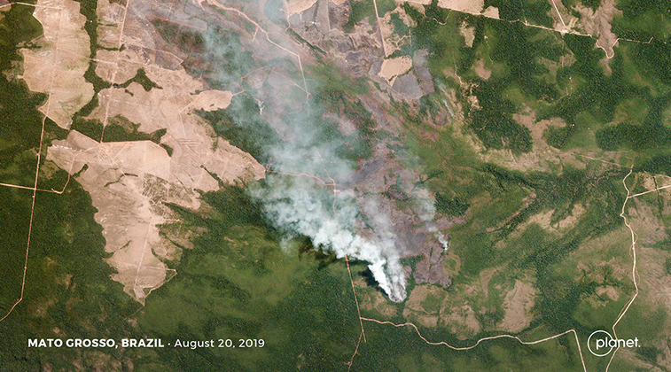

Figure 3 - The amazon fires being updated in real-time to give images to the public on the scale of devastation happening in the world's largest rainforest.5

The tech that Planet Labs has created with the Flock constellation has transformed the way we see Earth, and hopefully, it can prosper and continue to impact how we affect each other, and our home, the only one we have ever known.

Works Cited

1. “Planet Labs.” *Wikipedia*, Wikimedia Foundation, 18 Dec. 2019, en.wikipedia.org/wiki/Planet_Labs.
2. “Dove 1.” *Gunter's Space Page - Information on Spaceflight, Launch Vehicles and Satellites*, space.skyrocket.de/doc_sdat/dove-1.htm.
3. “Planet Labs Targets a Search Engine of the World.” *NASA Spaceflight*, Jan. 2018, [www.nasaspaceflight.com/2018/01/planet-labs-targets-search-engine-world/](http://www.nasaspaceflight.com/2018/01/planet-labs-targets-search-engine-world/).
4. “Planet - Flock Imaging Constellation.” *Flock 1 Constellation - Satellite Missions - EoPortal Directory*, 2018, directory.eoportal.org/web/eoportal/satellite-missions/f/flock-1.
5. “Satellite Imagery, Insight and Monitoring Solutions by Market.” *Planet*, 29 Apr. 2019, www.planet.com/markets/.